DESIGN A WEBPAGE FOR FRESH AND ORGANIC FOOD DELIVERY SYSTEM
A Mini Project submitted for the partial fulfilment of the requirement
for the award of the Degree of
MASTER OF COMPUTER APPLICATIONS
SUBMITTED BY
B JAYASURYA ROLL NO:1140024002
BISWARUP MANDAL ROLL NO:11400240007
D SRAVANI ROLLNO:11400240012
Under the Guidance of
Prof. T. ANURADHA, MCA., Ph.D.,

Department of Computer Science
DRAVIDIAN UNIVERSITY


DEPARTMENT OF COMPUTER SCIENCE
DRAVIDIAN UNIVERSITY
KUPPAM – 517425
BONAFIDE CERTIFICATE

This is to certify that the project work entitled “DESIGN A WEBPAGE FOR FRESH AND ORGANIC FOOD DELIVERY SYSTEM ” is a Bonafide work carried out by B. JAYSURYA (RollNo:11400240002), BISWARUP MANDAL (RollNo:114 00240007), D. SRAVANI (RollNo:11400240012) submitted in the partial fulfilment of the requirements for the award of Master of Computer Applications in Dravidian University, Kuppam during the academic year 2023- 2025.

INTERNAL GUIDE HEAD OF THE DEPARTMENT
Prof. T. ANURADHA Prof. K. AMMULU
MCA., Ph.D., B.Tech(CSE),M.Tech(C.S) Ph.D.,
Department Of Computer Science Department Of Computer Science

DECLARATION

We, B.JAYASURYA (RollNo:11400240002), BISWARUP MANDAL(RollNo:11400240007), D. SRAVANI (RollNo:11400240012) hereby declare that the project entitled “DESIGN A WEBPAGE FOR FRESH AND ORGANIC FOOD DELIVERY SYSTEM ”is done by us under the guidance of Prof. T. ANURADHA, MCA., Ph.D., submitted in partial fulfilment of the requirements for the award of degree of Master of Computer Applications at DRAVIDIAN UNIVERSITY, Kuppam during the academic year 2023-2025. This work has not been submitted by anybody towards the award of any degree.

DATE: [ Signature of the Students]

PLACE: KUPPAM

B. JAYASURYA

BISWARUP MANDAL

D. SRAVAN

ACKNOWLEDGEMENT

I would like to express my heartfelt gratitude to all those who supported me throughout the completion of my MCA mini project titled “DESIGN A WEBPAGE FOR FRESH AND ORGANIC FOOD DELIVERY SYSTEM ”.

I extend my sincere thanks to my project guide, Prof. T. ANURADHA, MCA., Ph.D., for their invaluable guidance and constant encouragement. Their insights and feedback were instrumental in shaping this project.

I am also grateful to my fellow classmates and friends for their support and collaboration. A special thanks to my family for their unwavering belief in my abilities and for providing me with the motivation to pursue my goals.

Finally, I would like to acknowledge the resources and references that contributed to the success of this project. Thank you all for being a part of this journey.

TABLE OF CONTENTS

CHAPTER | TITLE | PAGE NO
1 | Abstract | 6
2 | Introduction | 7
3 | Objective | 8-9
4 | Steps involves In designing a website | 10-11
5 | Hardware and software Requirement | 12
6 | Selected Software | 13-17
7 | System Module | 18
8 | Reference | 19
9 | Er-Diagram | 19
10 | Source Code | 20-46
11 | Output images | 47-51
12 | Conclusion | 52

1.ABSTRACT
This project focuses on designing a user-friendly webpage for an online food delivery system using HTML, CSS, JavaScript, and Bootstrap and PHP. The primary objective is to create an intuitive interface that allows users to browse a menu, view meal options, and easily place orders.

The webpage features a responsive layout, ensuring compatibility across various devices. A navigation bar facilitates seamless access to different sections, including the menu and contact information. The hero section captures user attention with engaging visuals and a call to action. Menu items are displayed in card format, each featuring images, descriptions, and "Add to Cart" buttons, enhancing the user experience.

JavaScript is utilized to provide interactive features, such as alerts when items are added to the cart. Bootstrap's framework ensures a consistent design and responsiveness, allowing for efficient scaling. This webpage serves as a foundational model for future enhancements, such as user accounts and payment integration, aiming to streamline the online food ordering process.

2.Introduction

Designing a webpage for a fresh and organic food delivery system involves creating a user-friendly and visually appealing platform that highlights the benefits of healthy eating. The website should effectively showcase a variety of organic products, emphasize freshness, and convey a commitment to sustainability. Key features might include:

- Clean and Intuitive Layout : Prioritize simplicity to ensure easy navigation and a pleasant user experience.

- Vibrant Imagery: Use high-quality images of fresh produce to engage visitors and illustrate the quality of the offerings.

- Clear Call to Action : Incorporate prominent buttons for placing orders, signing up for newsletters, or accessing recipes.

- Product Categories: Organize items by type (fruits, vegetables, pantry staples) to facilitate quick browsing.

- Sustainability Messaging : Highlight sourcing practices, eco-friendly packaging, and the health benefits of organic foods to resonate with environmentally conscious consumers.

- User Reviews and Testimonials : Include feedback from satisfied customers to build trust and credibility.

- Mobile Responsiveness: Ensure the site is fully functional on mobile devices for convenience.

By combining aesthetic appeal with practical functionality, the webpage can effectively attract and retain customers seeking fresh and organic food options.

3.Objectives:
The objectives of an online fresh and organic food delivery service typically focus on providing convenience, health benefits, and sustainable practices. Here are the key objectives for such a service:
- Convenience:
  - To offer a hassle-free shopping experience where customers can easily access fresh, organic foods without leaving their homes.
  - Provide a user-friendly platform (website or mobile app) for easy browsing, ordering, and payment.
- Health and Nutrition:
  - To promote healthier eating habits by offering fresh, organic food options free from harmful pesticides, chemicals, and preservatives.
  - Educate consumers about the benefits of organic produce and how it contributes to overall well-being.
- Quality Assurance:
  - Ensure that all products delivered are of the highest quality, maintaining freshness, flavour, and nutritional value.
  - Source products from trusted organic farms or suppliers that adhere to stringent standards.
- Sustainability:
  - Support eco-friendly farming practices that reduce environmental impact, such as crop rotation, water conservation, and minimal chemical use.
  - Use eco-friendly packaging materials to reduce waste and carbon footprint.
- Accessibility and Affordability:
  - Make organic food more accessible to a wider audience by offering delivery services to urban and rural areas.
  - Strive to keep prices competitive and affordable, breaking down the misconception that organic food is expensive.
- Customer Satisfaction:
  - Provide excellent customer service, including reliable and timely delivery, easy returns, and responsive support.
  - Tailor product offerings based on customer preferences, dietary needs, and seasonal availability.
- Building Local Communities:
  - Support local organic farmers and food producers, fostering community development and strengthening regional economies.
  - Create a network that connects consumers with the source of their food.
- Tracking and Transparency:
  - Offer transparency regarding the sourcing, production, and quality control processes of the food, including traceability from farm to table.
  - Provide tools for customers to track their orders and ensure timely delivery.
By fulfilling these objectives, an online fresh and organic food delivery service can meet the growing demand for healthy, sustainable, and convenient food options.

4.Steps involves In designing a website:

Building a website typically involves several phases in a software development cycle. Here’s a streamlined overview:

- Planning:
  - Define goals and objectives.
  - Identify target audience and requirements.
  - Create a sitemap and outline content structure.

- Design:
  - Develop wireframes or mockups.
  - Design user interface (UI) and user experience (UX).
  - Gather feedback and iterate on designs.

- Development:
  - Set up the development environment.
  - Code the front-end and back-end.
  - Integrate databases and APIs as needed.

- Testing:
  - Perform unit testing, integration testing, and user acceptance testing (UAT).
  - Identify and fix bugs or issues.

- Deployment:
  - Prepare the hosting environment.
  - Deploy the website to a live server.
  - Ensure all functionalities are working as intended.

- Maintenance:
  - Monitor performance and security.
  - Update content and software regularly.
  - Gather user feedback for future improvements.

- Iteration:
  - Based on user feedback and analytics, revisit planning and design as needed.
  - Implement new features or enhancements.

This cycle can be adapted and repeated as necessary to ensure the website remains effective and up-to-date

5.Hardware and Software Requirement:

HARDWARE REQUIREMENTS:

- Processer : Intel Core i5 processor
- Ram : 8 GB
- Hard disk : Based on system capacity.

SOFTWARE REQUIREMENTS:

- Web Technologies : HTML, CSS, JavaScript
- Plugins Bootstrap V5.
- Back end: json server

6.SELECTED SOFTWARE
  - FRONT END

Frontend is designed by using following technologies:
- HTML

- CSS

- JavaScript

BACK END
Backend is designed by using following technologies:
- PHP Server

- DATABASE

- Mysql

Frontend
HTML
- Here are the basic HTML elements without examples:
- <!DOCTYPE html> - Defines the document type and version of HTML.
- <html> - Root element of an HTML document.
- <head> - Contains metadata and links to external resources.
- <title> - Sets the title of the webpage.
- <meta> - Provides metadata such as character encoding and viewport settings.
- <body> - Contains the content of the web page visible to users.
- <h1> - <h6> - Define headings, with <h1> being the largest and <h6> the smallest.
- <p> - Represents a paragraph.
- <strong> - Defines important text (usually bold).
- <em> - Defines emphasized text (usually italicized).
- <br> - Inserts a line break.
- <ul> - Creates an unordered list.
- <ol> - Creates an ordered list.
- <li> - Represents a list item.
- <a> - Defines a hyperlink.
- <img> - Embeds an image.
- <video> - Embeds a video.
- <table> - Defines a table.
- <tr> - Defines a row in a table.
- <th> - Defines a header cell in a table.
- <td> - Defines a data cell in a table.
- <form> - Defines a form for user input.
- <input> - Defines an input field.
- <textarea> - Defines a multi-line text input field.
- <button> - Defines a clickable button.
- <div> - Defines a generic container for content.
- <section> - Defines a section of content.
- <footer> - Defines the footer of a document or section.
- <header> - Defines the header of a document or section.
- <aside> - Represents content that is tangentially related to the content around it.
- <nav> - Defines navigation links.
- <!-- --> - Used for adding comments in HTML code.

css
CSS (Cascading Style Sheets) is a language used to control the presentation and layout of web pages. It allows you to style HTML elements, including defining colors, fonts, spacing, positioning, and more. By separating content (HTML) from design (CSS), it makes websites easier to maintain and improves consistency across pages.

Types of CSS:
- Inline CSS
  - CSS rules are applied directly within an HTML element using the style attribute. It affects only the specific element it's applied to.
- Internal CSS
  - CSS rules are defined within a <style> block in the <head> section of an HTML document. These styles apply to elements in the specific document.
- External CSS
  - CSS rules are written in a separate .css file. The CSS file is linked to the HTML document using the <link> tag. This method is efficient for styling multiple pages and maintaining consistency across a website.

Key CSS Concepts:
- Selectors: Identify the HTML elements to apply styles to (e.g., element selectors, class selectors, ID selectors).
- Properties: Define the styles to be applied to the elements (e.g., color, font-size, margin).
- Values: Specify the setting for the property (e.g., red, 16px, 10px).
- Cascade: Refers to the order in which styles are applied. More specific styles override general ones, and styles declared later in the document take precedence over earlier ones.
- Specificity: Determines which style rule is applied when multiple rules target the same element, with more specific selectors taking precedence.
- Box Model: Defines the layout structure of elements. It includes the content, padding, border, and margin of an element.
- Positioning: Controls where elements are placed on the page using properties like static, relative, absolute, fixed, and sticky.
- Flexbox: A layout model that allows flexible, responsive design by distributing space dynamically within a container.
- Grid: A layout system that uses rows and columns to organize elements, providing more control over complex layouts.
- Responsive Design: CSS allows for creating designs that adapt to different screen sizes, typically using media queries.
- Transitions and Animations: Enable dynamic changes in styles and movements of elements over time.

Javascript
JavaScript is a high-level, interpreted programming language primarily used to create dynamic and interactive effects on web pages. It enables client-side scripting, allowing web pages to respond to user actions, such as clicks, form submissions, and mouse movements, without requiring a page reload. JavaScript is essential for building modern, responsive web applications and works alongside HTML and CSS as one of the three core technologies of the web.

Backend
Php
Definition of PHP
PHP (Hypertext Preprocessor) is a widely-used, open-source server-side scripting language designed for web development. It is particularly well-suited for creating dynamic web pages and applications. PHP can be embedded within HTML to produce web content dynamically, interact with databases, manage sessions, handle form submissions, and perform various server-side tasks.
PHP is executed on the server, meaning that it processes requests, performs logic, and generates HTML or other output to be sent to the client (browser). It supports a wide range of databases, including MySQL, PostgreSQL, and SQLite, and is often used in combination with front-end technologies like HTML, CSS, and JavaScript to build full-stack web applications.
PHP is open-source, meaning it is free to use and supported by a large community of developers. It is commonly used in content management systems (CMS) like WordPress, Drupal, and Joomla, as well as in frameworks such as Laravel, Symfony, and CodeIgniter.

Key Features of PHP:
- Server-side execution: PHP scripts are executed on the server, allowing for dynamic content generation.
- Embedded within HTML: PHP code can be embedded directly into HTML files, allowing developers to create dynamic pages easily.
- Database interaction: PHP has built-in support for interacting with databases (e.g., MySQL) to store and retrieve data.
- Cross-platform: PHP can run on various operating systems, such as Linux, Windows, and macOS, and is supported by most web hosting providers.
- Open-source: PHP is free to use, and there is extensive documentation and a large developer community.
Mysql
Definition of MySQL
MySQL is an open-source relational database management system (RDBMS) that uses Structured Query Language (SQL) to manage and manipulate data. It is one of the most popular database systems for web applications and is widely used in conjunction with server-side programming languages like PHP, Python, and JavaScript.
MySQL allows users to create, read, update, and delete (CRUD) data in structured tables, which are organized into rows and columns. It is commonly used to store and manage data for websites, applications, and services that require persistent storage, such as user accounts, product information, and transaction records.
MySQL is known for its reliability, speed, and flexibility, and it supports a variety of features such as transactions, indexing, data integrity, and security mechanisms. It is typically used in the LAMP stack (Linux, Apache, MySQL, PHP/Python) for building dynamic websites and applications.

Key Features of MySQL:
- Relational Database: Organizes data into tables, rows, and columns with relationships between different tables.
- SQL (Structured Query Language): Uses SQL to interact with the database for data insertion, retrieval, modification, and deletion.
- ACID Compliance: Ensures reliable transactions with features like atomicity, consistency, isolation, and durability.
- Scalability: Supports large databases and high-traffic applications.
- Security: Provides user authentication and data encryption to protect sensitive information.
- Cross-platform: Runs on a variety of operating systems, including Linux, Windows, and macOS.
- Open Source: MySQL is free and open-source, supported by a large community and commercial support from Oracle.

7.System module

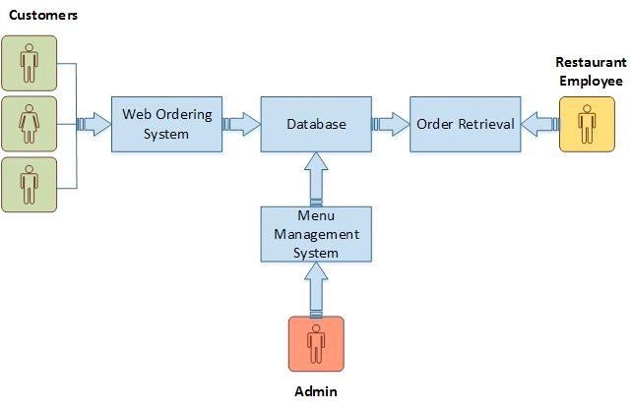

8.Reference

http://getbootstrap.com/
https://www.youtube.com/watch?v=oepmLGQP1m4&list=P LUoqTnNH- 2Xz_BUrjcahKWDhPcUj-FTOt

https://docs.oracle.com/cd/E24628_01/server.121/e41484.pdf
9.Er-Diagram
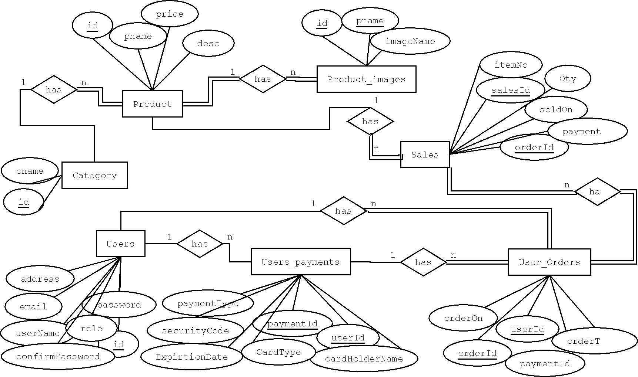
Source code:

Index.php

<?php
session_start();
$isLoggedIn = isset($_SESSION['user_id']);
?>

<!DOCTYPE html>
<html lang="en">

<head>
<meta charset="UTF-8">
<meta name="viewport" content="width=device-width, initial-scale=1.0">
<link rel="stylesheet" href="../CSS/style.css">
<link rel="stylesheet" href="https://cdn.jsdelivr.net/npm/bootstrap-icons@1.11.3/font/bootstrap-icons.min.css">
<link rel="stylesheet" href="https://cdn.jsdelivr.net/npm/swiper@11/swiper-bundle.min.css">
<!-- Latest version via CDN -->
<link href="https://cdnjs.cloudflare.com/ajax/libs/font-awesome/6.5.1/css/all.min.css" rel="stylesheet">
<!-- Bootstrap CSS -->
<link href="https://cdn.jsdelivr.net/npm/bootstrap@5.3.0-alpha1/dist/css/bootstrap.min.css" rel="stylesheet">

<script src="https://code.jquery.com/jquery-3.7.1.js" integrity="sha256-eKhayi8LEQwp4NKxN+CfCh+3qOVUtJn3QNZ0TciWLP4=" crossorigin="anonymous"></script>

</head>

<body>
<!-- header section start -->
<header class="header">
<a href="#" class="logo"><i class="bi bi-bag-heart"></i>gorco</a>
<nav class="navbar">
<a href="#home">home</a>
<a href="#features">features</a>
<a href="#product">product</a>
<a href="#categories">categories</a>
<a href="#review">review</a>
<a href="#blog">blogs</a>
</nav>
<div class="icons">
<div class="bi bi-bag-heart" id="menu-btn"></div>
<div class="bi bi-search-heart-fill" id="search-btn"></div>
<?php if ($isLoggedIn): ?>
<a>Welcome, <?php echo htmlspecialchars($_SESSION['first_name']); ?>!</a>
<a href="logout.php"><i class="fa-solid fa-right-from-bracket"></i></a>
<?php else: ?>
<a href="login.php">Login</a>
<a href="register.php">Signin</a>
<?php endif; ?>
<!-- Cart Icon -->
<!-- Cart/Wishlist Button -->
<div class="bi bi-bag-heart" id="cart-btn" data-bs-toggle="modal" data-bs-target="#cartModal"></div>

</div>
</header>

<section class="home" id="home">
<div class="content">
<h3>fresh and <span>organic</span> products for you</h3>
<p>Lorem, ipsum dolor sit amet consectetur adipisicing alit. Deserunt, earum!</p>
<a href="" class="btn">shop now</a>
</div>
</section>

<!-- header section end -->

<!-- feature section start-->
<section class="features " id="features">
<h1 class="heading">our <span>features</span></h1>
<div class="box-container">
<div class="box">
<img src="https://www.shutterstock.com/image-photo/wicker-basket-filled-fresh-vegetables-260nw-2465411187.jpg " alt="">
<h3>fresh and organic</h3>
<p>Lorem, ipsum dolor sit amet consectetur adipisicing alit. Deserunt, earum!</p>
<a href="" class="btn">read more</a>
</div>

<div class="box">
<img src="https://encrypted- tbn0.gstatic.com/images?q=tbn:ANd9GcRBxVVNNag6Ozkp4iq1GLL0JWWwf1REh6HXeA&s" alt="">
<h3>free delivery</h3>
<p>Lorem, ipsum dolor sit amet consectetur adipisicing alit. Deserunt, earum!</p>
<a href="" class="btn">read more</a>
</div>

<div class="box">
<img src="https://img.freepik.com/premium-vector/banking-service-online-get-credit-fast-easy-get-loan-via-smart-phone-application_566886-9965.jpg?size=626&ext=jpg&ga=GA1.1.739085926.1725458255&semt=ais_hybrid" alt="">
<h3>easy payment</h3>
<p>Lorem, ipsum dolor sit amet consectetur adipisicing alit. Deserunt, earum!</p>
<a href="" class="btn">read more</a>
</div>
</div>
</section>
<!--feature section end-->

<!--product section start-->
<section class="product" id="product">
<h1 class="heading">our <span>product</span></h1>
<div class="swiper product-slider">
<div class="swiper-wrapper">
<!-- Product 1: Fresh Orange -->
<div class="swiper-slide box">
<img src="../Images/items/orange.webp" alt="fresh orange">
<h3>fresh orange</h3>
<div class="price">rs: 99</div>
<div class="stars">
<i class="bi bi-star-fill"></i>
<i class="bi bi-star-fill"></i>
<i class="bi bi-star-fill"></i>
<i class="bi bi-star-fill"></i>
<i class="bi bi-star-half"></i>
</div>
<a href="#" class="btn"
data-image="../Images/items/orange.webp"
data-title="Fresh Orange" data-price="rs: 99">
Add to Cart
</a>
</div>

<!-- Product 2: Fresh Apple -->
<div class="swiper-slide box">
<img src="../Images/items/apple.jpg" alt="fresh apple">
<h3>fresh apple</h3>
<div class="price">rs: 120</div>
<div class="stars">
<i class="bi bi-star-fill"></i>
<i class="bi bi-star-fill"></i>
<i class="bi bi-star-fill"></i>
<i class="bi bi-star-fill"></i>
<i class="bi bi-star-fill"></i>
</div>
<a href="#" class="btn" data-bs-toggle="modal" data-bs-target="#productModal"
data-image="../Images/items/apple.jpg"
data-title="fresh apple" data-price="rs: 120">
add to cart
</a>
</div>

<!-- Product 3: Fresh Banana -->
<div class="swiper-slide box">
<img src="../Images/items/banana.jpg" alt="fresh banana">
<h3>fresh banana</h3>
<div class="price">rs: 60</div>
<div class="stars">
<i class="bi bi-star-fill"></i>
<i class="bi bi-star-fill"></i>
<i class="bi bi-star-fill"></i>
<i class="bi bi-star-half"></i>
<i class="bi bi-star"></i>
</div>
<a href="#" class="btn" data-bs-toggle="modal" data-bs-target="#productModal"
data-image="../Images/items/banana.jpg"
data-title="fresh banana" data-price="rs: 60">
add to cart
</a>
</div>

<!-- Product 4: Fresh Mango -->
<div class="swiper-slide box">
<img src="../Images/items/mango.jpg" alt="fresh mango">
<h3>fresh mango</h3>
<div class="price">rs: 150</div>
<div class="stars">
<i class="bi bi-star-fill"></i>
<i class="bi bi-star-fill"></i>
<i class="bi bi-star-fill"></i>
<i class="bi bi-star-fill"></i>
<i class="bi bi-star-fill"></i>
</div>
<a href="#" class="btn" data-bs-toggle="modal" data-bs-target="#productModal"
data-image="../Images/items/mango.jpg"
data-title="fresh mango" data-price="rs: 150">
add to cart
</a>
</div>

<!-- Product 5: Fresh Grape -->
<div class="swiper-slide box">
<img src="../Images/items/grapes.webp" alt="fresh grape">
<h3>fresh grape</h3>
<div class="price">rs: 140</div>
<div class="stars">
<i class="bi bi-star-fill"></i>
<i class="bi bi-star-fill"></i>
<i class="bi bi-star-fill"></i>
<i class="bi bi-star-fill"></i>
<i class="bi bi-star"></i>
</div>
<a href="#" class="btn" data-bs-toggle="modal" data-bs-target="#productModal"
data-image="../Images/items/grapes.webp"
data-title="fresh grape" data-price="rs: 140">
add to cart
</a>
</div>

</div>
</div>
</section>

<!-- product section end -->

<!-- categories section strat -->
<section class="categories" id="categories">
<h1 class="heading">product <span>categories</span></h1>
<div class="box-container">

<div class="box">
<img src="https://th.bing.com/th?id=OSK.HEROboZXMRGD1D2YnoBMfHXd7u_lMAyiOrePVTzFoDA5YY8&w=384&h=228&c=13&rs=2&o=6&pid=SANGAM" alt="">
<h3>vegitables</h3>
<p>upto 45% off</p>
<a href="#" class="btn">shop now</a>
</div>

<div class="box">
<img src="https://th.bing.com/th/id/OIP.22XOhxYrd_Pu__NkrGadMgHaEo?rs=1&pid=ImgDetMain" alt="">
<h3>fresh fruits</h3>
<p>upto 45% off</p>
<a href="#" class="btn">shop now</a>
</div>

<div class="box">
<img src="https://th.bing.com/th/id/OIP.LeXpjLaTpqgYiC-M-sKl2wAAAA?w=136&h=180&c=7&r=0&o=5&pid=1.7" alt="">
<h3>dairy products</h3>
<p>upto 45% off</p>
<a href="#" class="btn">shop now</a>
</div>

<div class="box">
<img src="https://th.bing.com/th/id/OIP.ZBvflqvKbXxA38_Aokzp7AHaFB?rs=1&pid=ImgDetMain" alt="">
<h3>fresh meat</h3>
<p>upto 45% off</p>
<a href="http://127.0.0.1:5501/ordernow.html" class="btn">shop now</a>
</div>
</div>
</section>
<!-- categories section end -->

<!-- review section strat -->
<section class="review" id="review">

<h1 class="heading">customer's <span>review</span></h1>
<div class="swiper review-slider">
<div class="swiper-wrapper">
<div class="swiper-slide box">
<img src="../Images/divya.jpg" alt="">
<p>Lorem, ipsum dolor sit amet consectetur adipisicing alit. Unde sunt fugiat dalore ipsum id est maxime ad tempore quasi tenetur</p>
<h3>N DIVYA</h3>
<div class="stars">
<i class="bi bi-star-fill"></i>
<i class="bi bi-star-fill"></i>
<i class="bi bi-star-fill"></i>
<i class="bi bi-star-fill"></i>
<i class="bi bi-star-half"></i>
</div>

</div>

<div class="swiper-slide box">
<img src="../Images/jayasurya.jpg" alt="">
<p>Lorem, ipsum dolor sit amet consectetur adipisicing alit. Unde sunt fugiat dalore ipsum id est maxime ad tempore quasi tenetur</p>
<h3>B JAYASURYA</h3>
<div class="stars">
<i class="bi bi-star-fill"></i>
<i class="bi bi-star-fill"></i>
<i class="bi bi-star-fill"></i>
<i class="bi bi-star-fill"></i>
<i class="bi bi-star-half"></i>
</div>

</div>

<div class="swiper-slide box">
<img src="../Images/suresh (2).jpg" alt="">
<p>Lorem, ipsum dolor sit amet consectetur adipisicing alit. Unde sunt fugiat dalore ipsum id est maxime ad tempore quasi tenetur</p>
<h3>S SURESH</h3>
<div class="stars">
<i class="bi bi-star-fill"></i>
<i class="bi bi-star-fill"></i>
<i class="bi bi-star-fill"></i>
<i class="bi bi-star-fill"></i>
<i class="bi bi-star-half"></i>
</div>

</div>

<div class="swiper-slide box">
<img src="../Images/mano.jpg" alt="">
<p>Lorem, ipsum dolor sit amet consectetur adipisicing alit. Unde sunt fugiat dalore ipsum id est maxime ad tempore quasi tenetur</p>
<h3>T MANO</h3>
<div class="stars">
<i class="bi bi-star-fill"></i>
<i class="bi bi-star-fill"></i>
<i class="bi bi-star-fill"></i>
<i class="bi bi-star-fill"></i>
<i class="bi bi-star-half"></i>
</div>

</div>
</div>
</div>
</section>
<!-- review section end -->

<!-- blog section start -->
<section class="blog" id="blog">
<div class="box-container">
<div class="box">
<img src="https://5.imimg.com/data5/SELLER/Default/2023/3/293863103/PZ/OB/CV/53171356/fresh-organic-vegetables-500x500.jpg" alt="">
<div class="content">
<div class="icons">
<a href=""><i class="bi bi-people"></i> by user</a>
<a href=""><i class="bi bi-calendar-day"></i> 11 may 2024</a>
</div>
<h3>fresh organic vegitables and fruits</h3>
<p>Lorem, ipsum dolor sit amet consectetur adipisicing alit. Veniam, expedita</p>
<a href="" class="btn">read more</a>
</div>
</div>
<div class="box">
<img src="https://5.imimg.com/data5/SELLER/Default/2020/10/OU/MO/SE/12605361/organic-tomato-250x250.jpg" alt="">
<div class="content">
<div class="icons">
<a href=""><i class="bi bi-people"></i> by user</a>
<a href=""><i class="bi bi-calendar-day"></i> 11 may 2024</a>
</div>
<h3>fresh organic vegitables and fruits</h3>
<p>Lorem, ipsum dolor sit amet consectetur adipisicing alit. Veniam, expedita</p>
<a href="" class="btn">read more</a>
</div>
</div>
<div class="box">
<img src="https://5.imimg.com/data5/SELLER/Default/2023/3/293868480/UT/MC/UL/53171356/fresh-organic-vegetables-500x500.jpg" alt="">
<div class="content">
<div class="icons">
<a href=""><i class="bi bi-people"></i> by user</a>
<a href=""><i class="bi bi-calendar-day"></i> 11 may 2024</a>
</div>
<h3>fresh organic vegitables and fruits</h3>
<p>Lorem, ipsum dolor sit amet consectetur adipisicing alit. Veniam, expedita</p>
<a href="" class="btn">read more</a>
</div>
</div>

</div>
</section>
<!-- blog section end -->

<!-- footer section start -->
<section class="footer">
<div class="box-container">
<div class="box">
<h3>groco <i class="bi bi-bag-heart"></i></h3>
<p>Lorem, ipsum dolor sit amet consectetur adipisicing alit. Aliquam saepe. </p>
<div class="share">
<a href="#" class="bi bi-facebook"></a>
<a href="#" class="bi bi-twitter"></a>
<a href="#" class="bi bi-instagram"></a>
<a href="#" class="bi bi-linkedin"></a>
</div>
</div>

<div class="box">
<h3>contact information </h3>
<a href="" class="link"><i class="bi bi-phone"></i> +91 9676272156</a>
<a href="" class="link"><i class="bi bi-phone"></i> +91 9676272156</a>
<a href="" class="link"><i class="bi bi-envelope-at-fill"></i> sachinsurya9676@gmail.com</a>
<a href="" class="link"><i class="bi bi-globe-central-south-asia"></i> kuppam,chittoor,andhra pradesh,india</a>
</div>

<div class="box">
<h3>quick access</h3>
<a href="#home"><i class="bi bi-arrow-right"></i> home</a>
<a href="#features"><i class="bi bi-arrow-right"></i> features</a>
<a href="#product"><i class="bi bi-arrow-right"></i> product</a>
<a href="#categories"><i class="bi bi-arrow-right"></i> categories</a>
<a href="#review"><i class="bi bi-arrow-right"></i> review </a>
<a href="#blog"><i class="bi bi-arrow-right"></i> blog</a>

</div>

<div class="box">
<h3>newsletter</h3>
<p>subscribe for latest updates</p>
<input type="email" placeholder="your email" class="email">
<input type="submit" value="subscribe" class="btn">
<img src="" alt="">

</div>
</div>
</section>

<!-- footer section end -->

<footer style="text-align: center;">Copyright © 2024-2025 OnlineFoodShop.
All Rights are reserved</footer>

<!-- Modal -->
<!-- Cart Modal -->
<!-- Cart Modal -->
<div class="modal fade" id="cartModal" tabindex="-1" aria-labelledby="cartModalLabel" aria-hidden="true">
<div class="modal-dialog">
<div class="modal-content">
<div class="modal-header">
<h5 class="modal-title" id="cartModalLabel">Your Cart</h5>
<button type="button" class="btn-close" data-bs-dismiss="modal" aria-label="Close"></button>
</div>
<div class="modal-body">
<ul id="cartItemsList">
<!-- Cart items will be dynamically inserted here -->
</ul>
</div>
<div class="modal-footer">
<button type="button" class="btn btn-secondary" data-bs-dismiss="modal">Close</button>
</div>
</div>
</div>
</div>

<!-- Toast Notification -->
<div id="toast" class="toast align-items-center text-white bg-success border-0 position-fixed top-0 end-0 m-3" role="alert" aria-live="assertive" aria-atomic="true" style="z-index: 1050;">
<div class="d-flex justify-content-between">
<div class="toast-body">
Item added to cart!
</div>
<button type="button" class="btn-close btn-close-white" data-bs-dismiss="toast" aria-label="Close"></button>
</div>
</div>

<script src="https://cdn.jsdelivr.net/npm/bootstrap@5.3.0-alpha1/dist/js/bootstrap.bundle.min.js"></script>
</body>

<script src="https://cdn.jsdelivr.net/npm/swiper@11/swiper-bundle.min.js"></script>
<script src="../JavaScript/script.js"></script>
<!-- Include JavaScript file -->
<script src="https://cdnjs.cloudflare.com/ajax/libs/font-awesome/6.5.1/js/all.min.js"></script>

<script>
// Array to store cart items
let cartItems = [];

// Function to handle adding item to the cart
function addToCart(button) {
// Get product details from the data attributes of the clicked button
const productImage = button.getAttribute('data-image');
const productTitle = button.getAttribute('data-title');
const productPrice = button.getAttribute('data-price');

// Create a cart item object
const cartItem = {
image: productImage,
title: productTitle,
price: productPrice
};

// Add the item to the cart array
cartItems.push(cartItem);

// Show toast notification
const toast = new bootstrap.Toast(document.getElementById('toast'));
toast.show();

// Optionally, update the cart modal with all items
updateCartModal();
}

// Function to update the cart modal with all items in the cart
function updateCartModal() {
const cartItemsList = document.getElementById('cartItemsList');
cartItemsList.innerHTML = ''; // Clear current list

// Loop through the cart items and display them
cartItems.forEach(item => {
const listItem = document.createElement('li');
listItem.classList.add('d-flex', 'align-items-center', 'mb-3');
listItem.innerHTML = `
<img src="${item.image}" alt="${item.title}" class="img-fluid" style="width: 50px; height: 50px; object-fit: cover; margin-right: 10px;">
<div>
<strong>${item.title}</strong><br>
<span>${item.price}</span>
</div>
`;
cartItemsList.appendChild(listItem);
});
}

// Event listeners for the Add to Cart buttons
document.querySelectorAll('.btn').forEach(button => {
button.addEventListener('click', function(event) {
event.preventDefault(); // Prevent modal from opening
addToCart(button); // Add item to cart and show toast
});
});
</script>

</body>

</html>

Register.php

<!DOCTYPE html>
<html lang="en">
<head>
<meta charset="UTF-8">
<meta name="viewport" content="width=device-width, initial-scale=1.0">
<title>Register</title>
<!-- Bootstrap CSS -->
<link href="https://cdn.jsdelivr.net/npm/bootstrap@5.3.0-alpha1/dist/css/bootstrap.min.css" rel="stylesheet">
</head>
<body class="bg-light d-flex align-items-center justify-content-center vh-100">

<div class="container">
<div class="row justify-content-center">
<div class="col-md-6 col-lg-5">
<form class="registration-form p-4 bg-white rounded shadow" method="post" action="../PHP/registration.php">
<h3 class="text-center mb-4">Register Now</h3>

<div class="mb-3">
<input type="text" placeholder="Enter Your First Name" name="first_name" class="form-control" required>
</div>

<div class="mb-3">
<input type="text" placeholder="Enter Your Last Name" name="last_name" class="form-control" required>
</div>

<div class="mb-3">
<input type="email" placeholder="Your Email" name="mail" class="form-control" required>
</div>

<div class="mb-3">
<input type="password" placeholder="Your Password" name="password" class="form-control" required>
</div>

<div class="mb-3">
<input type="password" placeholder="Confirm Password" name="cnpassword" class="form-control" required>
</div>

<button type="submit" class="btn btn-primary w-100">Register Now</button>
</form>
</div>
</div>
</div>

<!-- Bootstrap JavaScript Bundle (optional) -->
<script src="https://cdn.jsdelivr.net/npm/bootstrap@5.3.0-alpha1/dist/js/bootstrap.bundle.min.js"></script>
</body>
</html>

Login.php

<!DOCTYPE html>
<html lang="en">
<head>
<meta charset="UTF-8">
<meta name="viewport" content="width=device-width, initial-scale=1.0">
<title>Login</title>
<!-- Bootstrap CSS -->
<link href="https://cdn.jsdelivr.net/npm/bootstrap@5.3.0-alpha1/dist/css/bootstrap.min.css" rel="stylesheet">
</head>
<body class="bg-light d-flex align-items-center justify-content-center vh-100">

<div class="container">
<div class="row justify-content-center">
<div class="col-md-6 col-lg-4">
<form class="login-form p-4 bg-white rounded shadow" method="post" action="../PHP/login.php">
<h3 class="text-center mb-4">Login Now</h3>

<?php
session_start();
if (isset($_SESSION['error'])) {
echo "<p class='text-danger text-center'>" . $_SESSION['error'] . "</p>";
unset($_SESSION['error']);
}
?>

<div class="mb-3">
<input type="email" placeholder="Your email" name="username" class="form-control" required>
</div>

<div class="mb-3">
<input type="password" placeholder="Your password" name="password" class="form-control" required>
</div>

<p class="text-center"><a href="#" class="text-decoration-none">Forget your password? Click here</a></p>

<div class="d-flex justify-content-between align-items-center mb-3">
<span>Don’t have an account?</span>
<a href="../HTML/register.php" id="createnow" class="text-decoration-none">Create now</a>
</div>

<button type="submit" name="submit" class="btn btn-primary w-100">Login</button>
</form>
</div>
</div>
</div>

<!-- Bootstrap JavaScript Bundle (optional) -->
<script src="https://cdn.jsdelivr.net/npm/bootstrap@5.3.0-alpha1/dist/js/bootstrap.bundle.min.js"></script>
</body>
</html>

Logout.php

<?php
session_start(); // Start the session
session_unset(); // Unset all session variables
session_destroy(); // Destroy the session
header("Location: ../HTML/login.php"); // Redirect to the login page
exit(); // Ensure no further code is executed

style.css

* {
font-family: Cambria, Cochin, Georgia, Times, 'Times New Roman', serif;
margin: 0;
padding: 0;
box-sizing: border-box;
outline: none;
border: none;
text-decoration: none;
text-transform: capitalize;
transition: all .2s linear;
}
:root{
--orange:#ff7800;
--black:#130f40;
--light-color:#666;
--box-shadow:0 0 .3rem .3rem rgba(0,0,0,.3);
--border:.2rem solid rgba(0,0,0,.1);
--outline:.1rem solid rgba(0,0,0,.1);
--outline-hover:.2rem solid var(--black);
}
html{

font-size: 62.5%;
/* overflow: hidden; */
scroll-behavior:smooth;
scroll-padding-top: 3rem;
}
body{
background: #eee;
}
section{
padding: 2rem 9%;
}
.btn{
margin-top: 2rem;
display: inline-block;
padding: .5rem 2rem;
font-size: 1.5rem;
border-radius: .5rem;
border: .2rem solid black;
color: var(--black);
cursor: pointer;
text-align: center;
width: 10rem;
}
.btn:hover{
background: var(--orange);
color: #fff;
}
.header{
position: fixed;
top: 0;
left: 0;
right: 0;
z-index: 1000;
display: flex;
align-items: center;
justify-content: space-between;
padding: 2rem 9%;
background: #fff;

}

.header .logo{
font-size: 2.5rem;
font-weight: bolder;
color: var(--black);
}
.header .logo i{
color: var(--orange);
}
.header .navbar a{
font-size: 2rem;
margin: 0 1rem;
color: var(--black);

}
.header .navbar a:hover{
color: var(--orange);
}
.header .navbar .select{
width: 10rem;
font-size:2rem ;
color: var(--black);
}
.header .icons{
display: flex;
justify-content: space-around;

}
.header .icons div{

width: 2rem;

border-radius: .5rem;
background: #fff;
color: var(--black);
font-size: 2rem;

text-align: center;
cursor: pointer;
padding: 2rem;
}
.header .icons a{
color: var(--black);
font-size: 2rem;
padding: 2rem;
cursor: pointer;

}
.header .icons a:hover{
color: var(--black);
font-size: 1rem;

cursor: pointer;
color:var(--orange);

}
.header .icons div:hover{
background: var(--orange);
color: #fff;
}
#menu-btn{
display: none;
}
.header .search-form{
position: absolute;
top: 110%;
right: 2rem;
width: 50rem;
height: 4.5rem;
background: #fff;
border-radius: .5rem;
overflow: hidden;
display: flex;
align-items: center;
box-shadow: var(--box-shadow);
}
.header .search-form{
right: 2rem;
transform: .4s linear;
}
.header .search-form input{
height: 100%;
width: 100%;
background: none;
text-transform: none;
font-size: 1.6rem;
color: var(--black);
padding: 0 1.5rem;
}
.header .search-form label{
font-size: 2.2rem;
padding-right: 1.5rem;
color: var(--black);
cursor: pointer;
}
.header .search-form label:hover{
color: var(--orange);
}

.home{
display: flex;
align-items: center;
justify-content: center;
background:url("https://media.geeksforgeeks.org/wp-content/uploads/20240711124309/8513909_3941598-(2).jpg")no-repeat ;
background-position: center;
background-size: cover;

padding-top: 17rem;
padding-bottom: 10rem;
}
.home .content{
display: block;
align-items: center;
justify-content: center;
background-color: #fff;
border-radius: 1rem;
}
.home .content p{
text-align: center;
font-size: 2rem;

}
.home .content h3{
text-align: center;
font-size: 2.5rem;
}
.home .content .btn{
text-align: center;
align-items: center;
justify-content: center;
}

#row1 {
color: black;
font-weight: bold;
font-size: 2rem;
text-align: center;
margin-top: 35px;
}
.btn{
border: 1px solid black;
border-radius: 3px;
width: 150px;
}
.btn:hover{
background-color:var(--orange);
border: 1px solid black;
border-radius: 3px;

font-weight: bolder;
color: white;
}
.heading{
text-align: center;
padding: 2rem 0;
padding-bottom: 2rem;
font-size: 2rem;
color: var(--black);
}
.heading span{
margin-top: 3rem;
background-color: var(--orange);
color: #fff;
display: inline-block;
padding: .4rem 3rem;
clip-path:polygon(100% 0,93% 50%,100% 99%,0% 100%,7% 50%,0% 0%) ;
}
.h{
text-align: center;
padding: 2rem 0;
padding-bottom: 2rem;
font-size: 2rem;
color: var(--black);
font-weight: bold;
}
.h .s{
background-color:cornflowerblue;
border-radius: 8px;
color:white;
display: inline-block;
padding: .4rem 3rem;
font-weight: bold;
clip-path:polygon(100% 0,93% 50%,100% 99%,0% 100%,7% 50%,0% 0%) ;
}
.features .box-container{

display: grid;
grid-template-columns: repeat(auto-fit, minmax(30rem,1fr));
gap: 2rem;

}
.features .box-container .box{
padding:3rem 2.5rem ;
background: #fff;
outline: var(--outline);
outline-offset: -1rem;
text-align: center;
box-shadow: var(--box-shadow);
}
.features .box-container .box:hover{
outline: var(--outline-hover);
outline-offset: .7rem;
}
.features .box-container .box img{
margin: 5rem 0;
height: 15rem;
width: 100%;
}
.features .box-container .box h3{
font-size: 2rem;
line-height: 0.8;
color: var(--black);
}
.features .box-container .box p{
font-size: 1.5rem;
line-height: 1.8;
color: var(--light-color);
padding: 0.5rem;
}
.product .product-slider:first-child{
margin-bottom: 2rem;
}

.product .product-slider .box{
background-color: #fff;
border-radius: .5rem;
text-align: center;
padding: 3rem 2.5rem;
outline-offset: -1rem;
outline: var(--outline);
box-shadow: var(--box-shadow);
transition: .2s linear;
margin-bottom: 2rem;
}
.product .product-slider .box:hover{
outline-offset: -1rem;
outline: var(--outline-hover);

}
.product .product-slider .box img{
height: 25rem;
width: 100;
}
.product .product-slider .box .price{
font-size: 2rem;
color: var(--light-color);

padding: .5rem 0;
}
.product .product-slider .box h3{
font-size: 2rem;
}
.product .product-slider .box .stars i{
font-size: 1.7rem;
color: var(--orange);
padding: .5rem 0;
}
.categories .box-container{

display: grid;
grid-template-columns: repeat(auto-fit, minmax(20rem,1fr));
gap: 1.5rem;
}
.categories .box-container .box{
padding: 3rem 2rem;
border-radius: .5rem;
background-color: #fff;
/* box-shadow: var(--box-shadow); */
outline: var(--outline);
outline-offset: -1rem;
text-align: center;
}
.categories .box-container .box:hover{
outline: var(--outline-hover);
outline-offset: 0rem;
}
.categories .box-container .box img{
margin: 0rem 0rem;
height: 20rem;
width: 100%;
}
.categories .box-container .box h3{
font-size: 2rem;
line-height: 0.8;
color: var(--black);
}
.categories .box-container .box p{
font-size: 1.5rem;
line-height: 1.8;
color: var(--light-color);
padding: 0.5rem 0rem;
}
.review .review-slider{
padding: 1rem;

}
.review .review-slider .box{
background-color: #fff;
border-radius: .5rem;
text-align: center;
padding: 3rem 2rem;
outline-offset: -2rem;
outline: var(--outline);
/* box-shadow: var(--box-shadow); */
transition: .2s linear;
}
.review .review-slider .box:hover{
outline-offset: 0rem;
outline: var(--outline-hover);
}
.review .review-slider .box img{
height: 17rem;
width: 100;
border-radius: 50%;
}
.review .review-slider .box p{
font-size: 1.5rem;
color: var(--light-color);
padding: 0.1rem;
}
.review .review-slider .box h3{
font-size: 2rem;
padding-bottom: .5rem;
color: var(--black);
}
.review .review-slider .box .stars i{
color: var(--orange);
font-size: 1.7rem;
}
.blog .box-container{

display: grid;
grid-template-columns: repeat(auto-fit, minmax(20rem,1fr));
gap: 1.5rem;
}
.blog .box-container .box{
overflow: hidden;
border-radius: .5rem;
/* box-shadow:var(--box-shadow); */
background: #fff;
outline: var(--outline);
}
.blog .box-container .box img{
height: 15rem;
width: 100%;
object-fit: cover;
}
.blog .box-container .box .content{
padding: 2rem;
}
.blog .box-container .box .content .icons{
display: flex;
align-items: center;
justify-content: space-between;
padding-bottom: 1.5rem;
margin-bottom: 1rem;
border-bottom: var(--border);
}
.blog .box-container .box .content .icons a{
color: var(--light-color);
font-size: 1.5rem;
text-decoration: none;
}
.blog .box-container .box .content .icons a:hover{
color: var(--black);

}
.blog .box-container .box .content .icons a i{
color: var(--orange);
padding-right: .5rem;

}
.blog .box-container .box .content h3{
line-height: 1.4;
color: var(--black);
font-size: 2.2rem;
padding: .5rem 0;
}
.blog .box-container .box .content p{
line-height: 1.4;
color: var(--black);
font-size: 1.5rem;
padding: .5rem 0;
}
.footer .box-container{

display: grid;
grid-template-columns: repeat(auto-fit, minmax(13rem,1fr));
gap: 1.5rem;
/* background-color: #fff; */

background: rgb(13, 12, 100);
background: -moz-linear-gradient(90deg, rgba(13, 12, 100, 1) 0%, rgba(42, 4, 75, 1) 26%);
background: -webkit-linear-gradient(90deg, rgba(13, 12, 100, 1) 0%, rgba(42, 4, 75, 1) 26%);
background: linear-gradient(90deg, rgba(13, 12, 100, 1) 0%, rgba(42, 4, 75, 1) 26%);
filter: progid:DXImageTransform.Microsoft.gradient(startColorstr="#0d0c64", endColorstr="#2a044b", GradientType=1);

}
.footer .box-container .box h3{
line-height: 1.4;
color: #fff;
font-size: 1.9rem;
padding-top: 2rem;
color: var(--orange);
}
.footer .box-container .box .share a{
line-height: 1.4;
color: var(--black);
font-size: 1.9rem;
padding-top: 2rem;
color: var(--orange);
padding-left: 1rem;
}
.footer .box-container .box i{
color: var(--orange);
padding-right: .2rem;

}
.footer .box-container .box a{
display: block;
font-size: 2rem;
color: #fff;
padding: 1.8rem 0;
}
.footer .box-container .box a:hover i{
color: var(--orange);
padding-right: 1rem;
}
.footer .box-container .box p{
line-height: 1.8;
font-size: 1.8rem;
color: #fff;
padding: 1rem 0;
}
.footer .box-container .box input{
padding-bottom: 1rem;
}
.logoco{
display: grid;
gap: 2rem;

}
.logoco .logo{
display: flex;
gap: 14rem;
}

@media (max-width:991px)
{
html{

font-size: 55%;

}
.header{
padding: 2rem;
}
}
@media (max-width:768px){
#menu-btn{
display: inline-block;
}
.header .search-form{
width: 90%;
}
.header .navbar{
position: absolute;
top: 110%;
right: -110%;width: 30rem;
box-shadow: var(--box-shadow);
border-radius: .5rem;
background-color: #fff;
}
.header .navbar.active{
right: 2rem;
transition: .4s linear;
}
.header .navbar a{
font-size: 2rem;
margin: 2rem 2.5rem;
display: block;
}
}
@media (max-width:450px)
{
html{

font-size: 50%;

}
}

Web Application images:

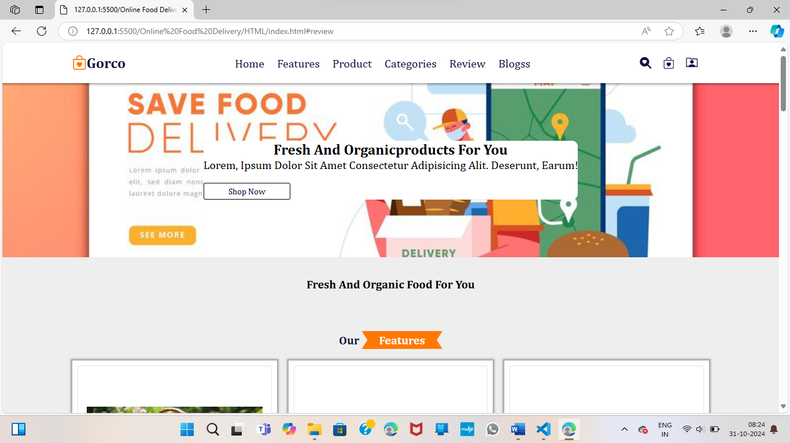

Fig: 1

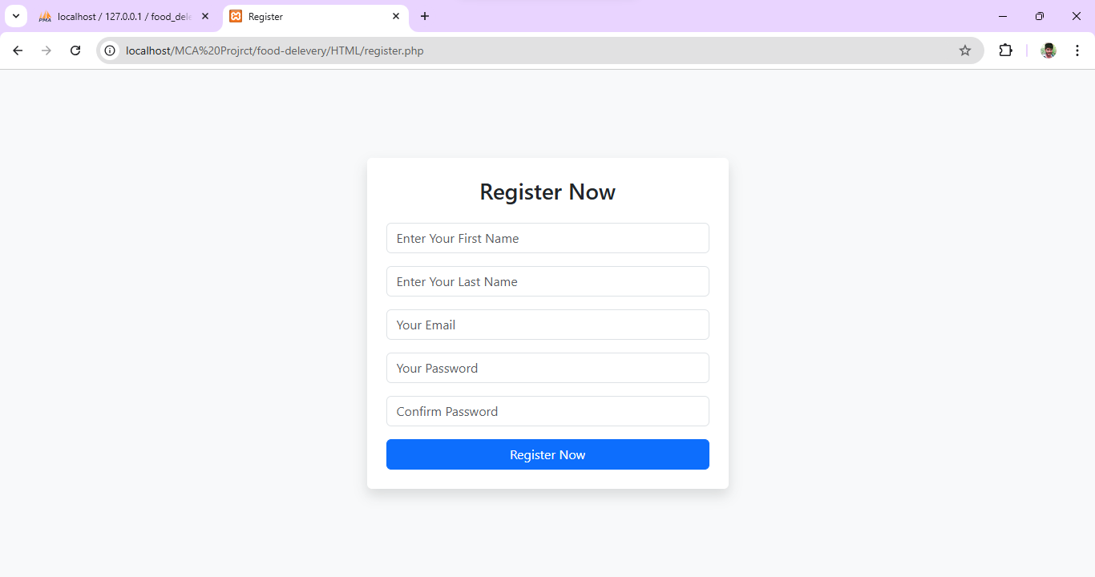

Fig: 2

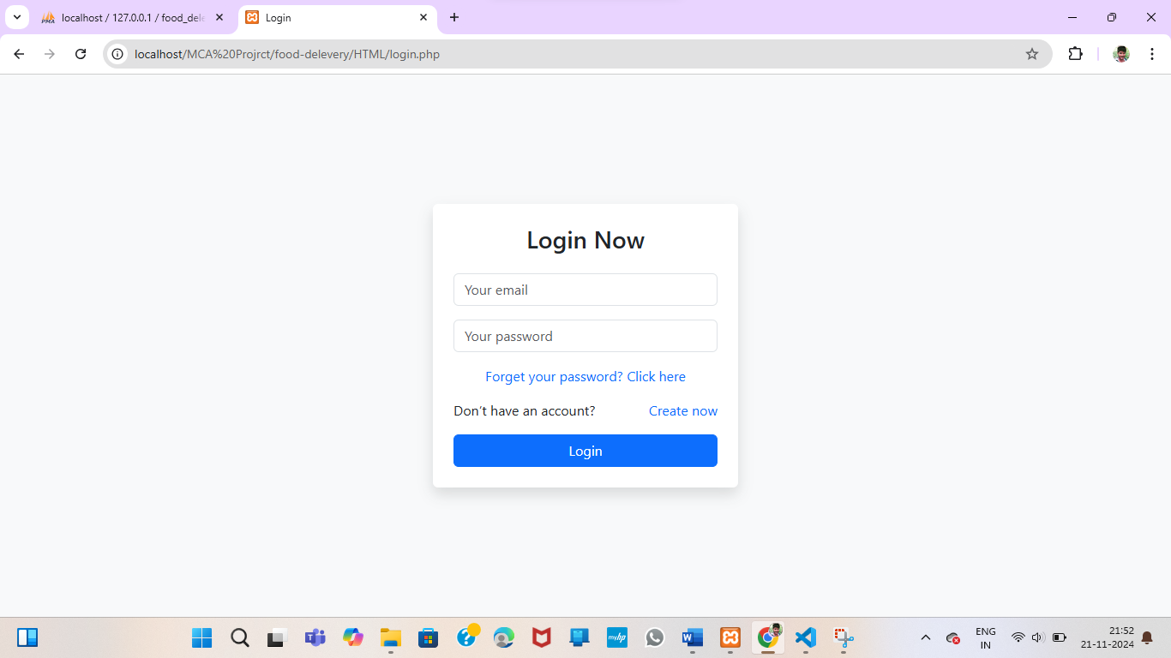

Fig: 3

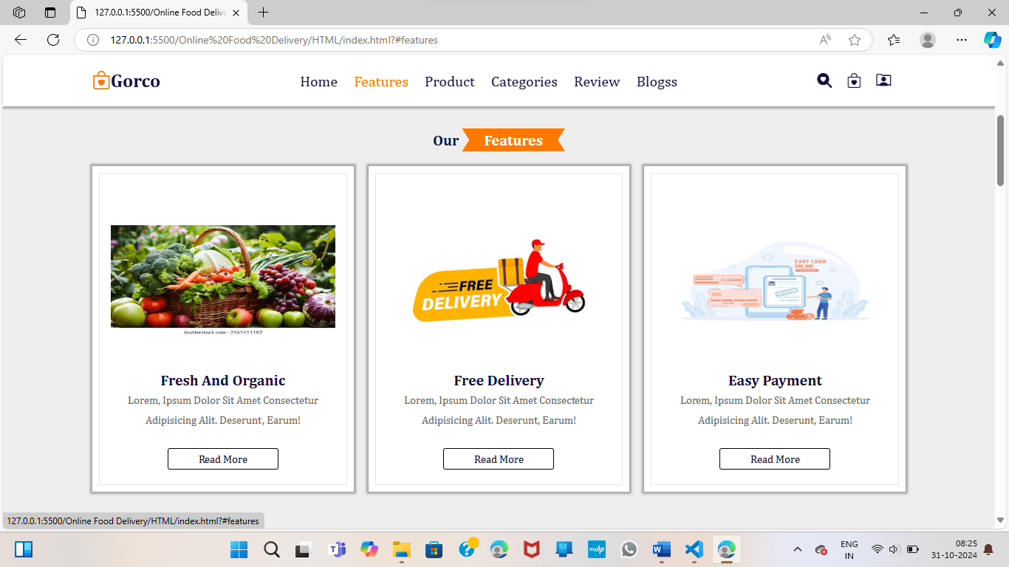
Fig: 4

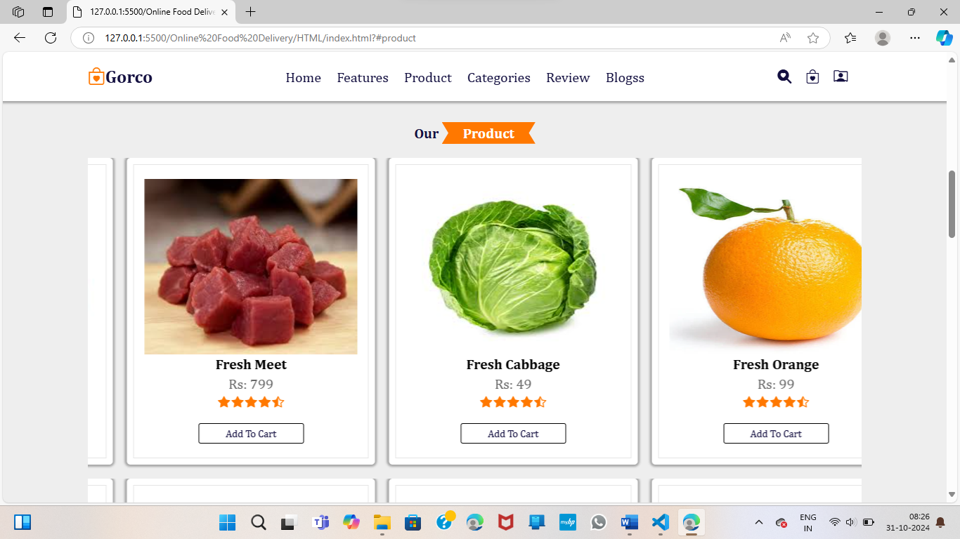

Fig: 5

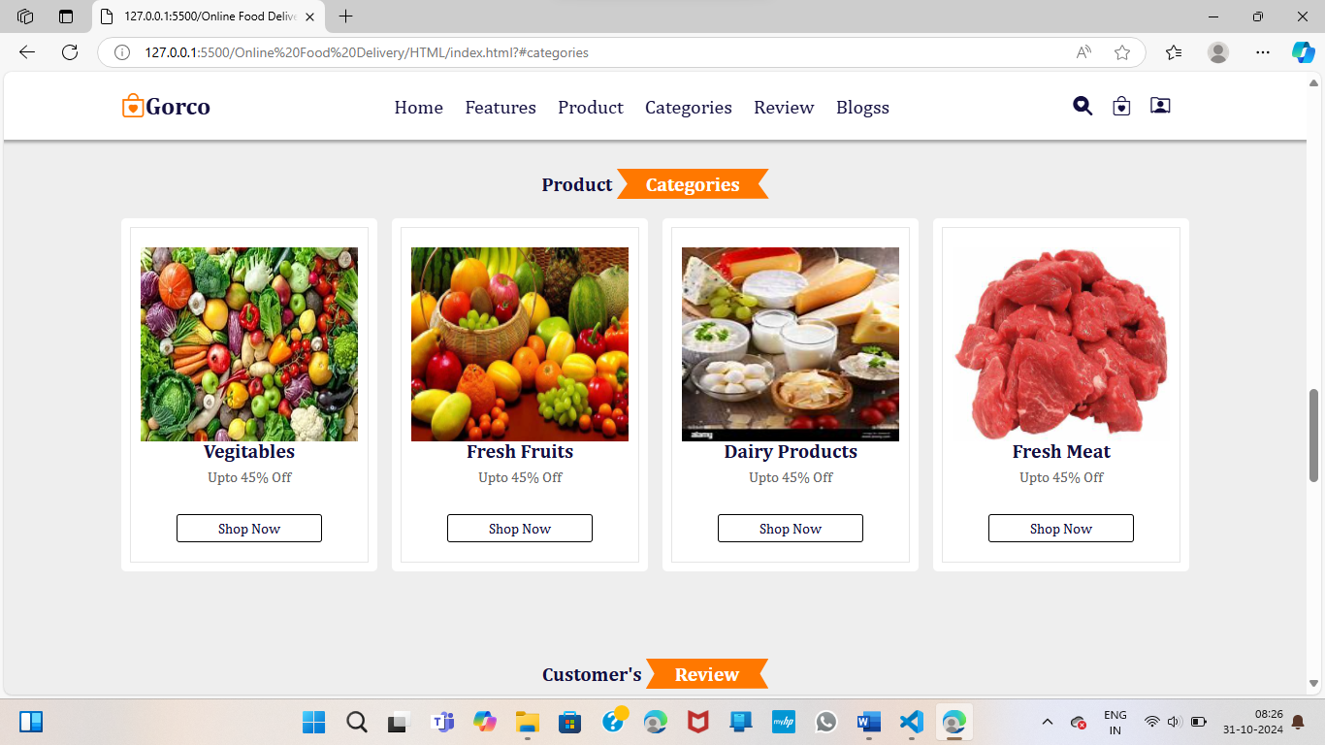
Fig: 6

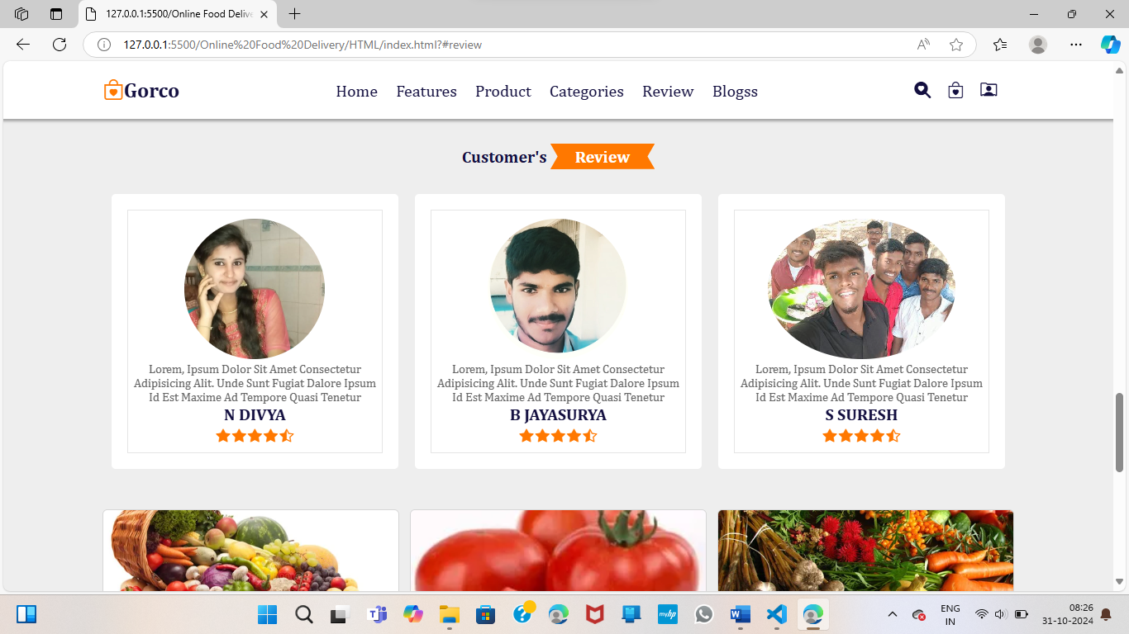

Fig: 7

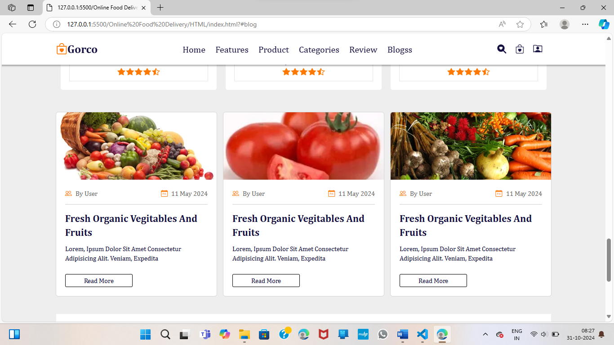
Fig: 8

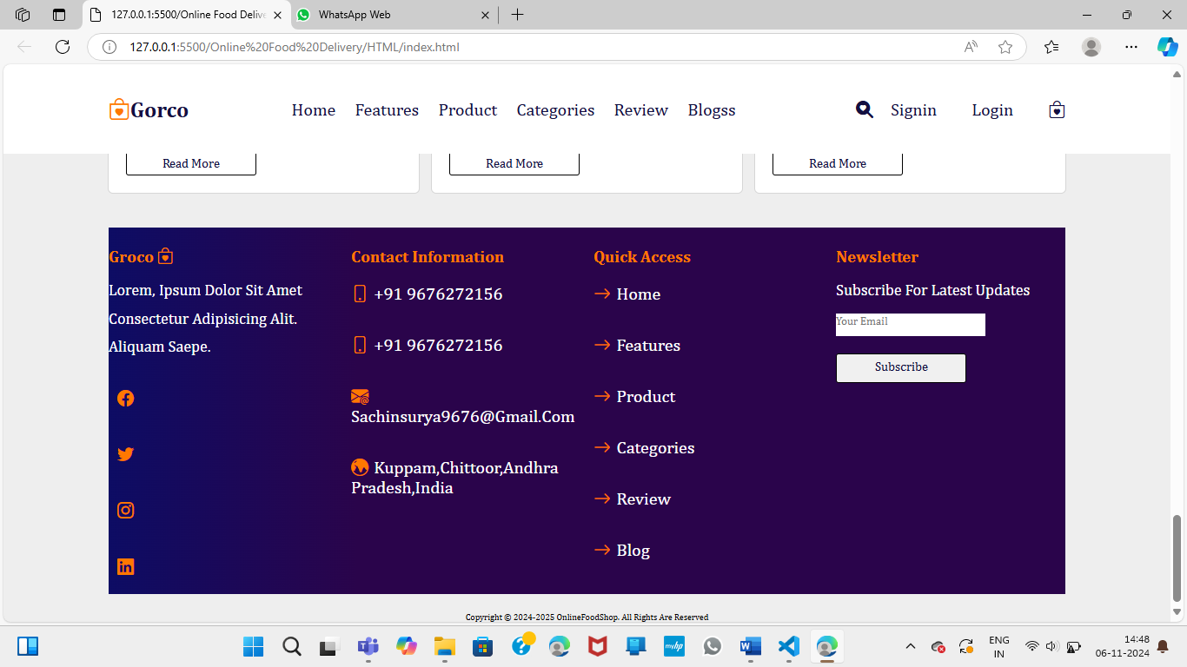
Fig: 9

Conclusion
A fresh and organic food delivery system requires careful planning and implementation to meet user needs while addressing logistical challenges. By focusing on usability, security, and efficient operations, the system can successfully connect consumers with fresh, local produce.

